W311R (W311R+)-How to set port range forwarding for Wireless Router (R)?
Product line: wireless Question category: function configuration

Q: why we want to configure port range forwarding?
A：Port Range Forwarding allows remote computers, for example, computers on the Internet, to access some kinds of public services such as web servers, ftp, e-mail and other specialized Internet applications on your local network（LAN）.

The topology is as following
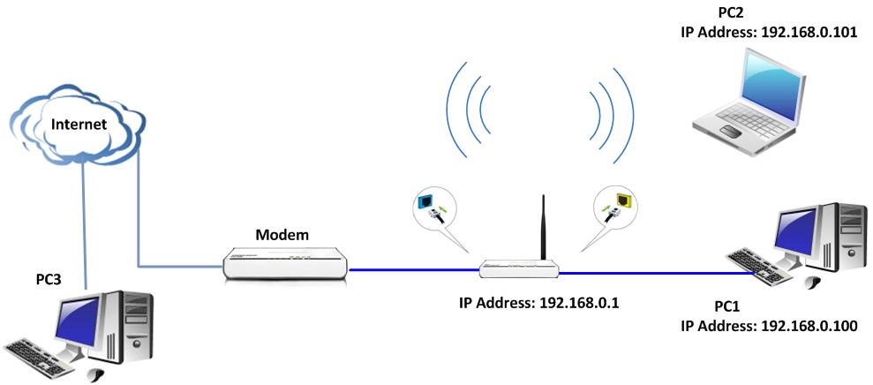

The steps are as below:

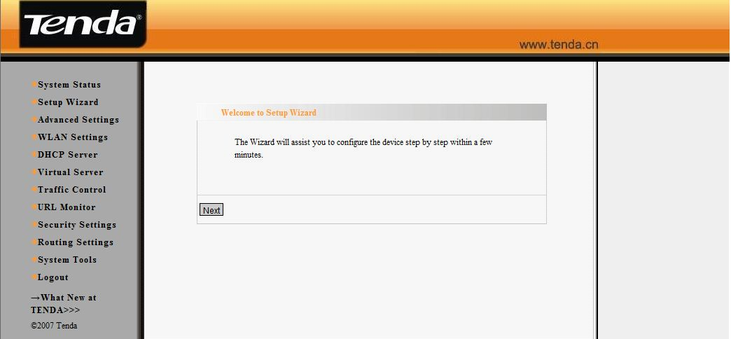

1. Connect your computer to the yellow LAN port with Ethernet cable and the blue Wan port connect to modem’s LAN port with Ethernet cable .Then you can login to the homepage of the Wireless Router and the following page will appear.
2. First you should run a server (e.g. FTP server) on your computer.

Click start→run and type cmd in the blank. In the new window, please type netstat -an. Then you can check whether the FTP server has been run successfully.

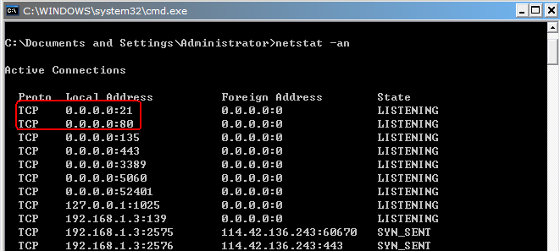

3. On the PC2, You can enter ftp://192.168.0.100 in the address bar in web browser to check whether you can access the server in the same LAN.

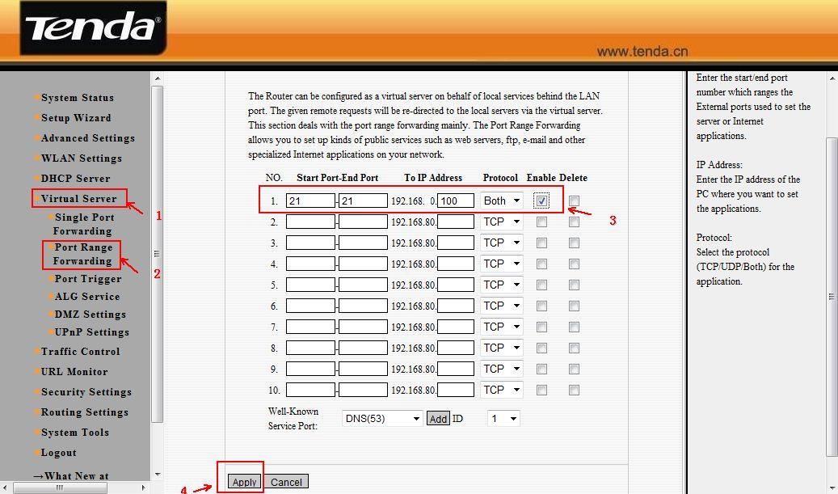

4. Then please click Virtual Server →Port Range Forwarding. Choose ftp (21) as well-known service ports. Type 100 in the blank of LAN IP and type 21 in the Start port and End port in the blank. Choose both as protocol and click enable.
5. After you click ok to save the setting, you can access the FTP server of PC1 on the PC3. Please enter ftp://WAN ip (example: ftp://1.1.1.1) in the address bar to access the FTP Server.

